
Land Information Ontario (LIO) Warehouse
Data Class Name: Forest Processing Facility
Documentation
Produced by: Information Access and Information Management Policy Unit
Ministry of Natural Resources and Forestry
Date: July 27, 2015

Purpose

This document provides additional information to support the use of geospatial data. The Physical Model Diagram provides a visual representation of the relationships in the data class. The Data Change History lists all the modelling and access changes that have occurred during the lifecycle of the data class. A data description identifying table and field names is available upon request.

Need Assistance?
Please contact LIO Support at lio@ontario.ca or 705-755-1878 if you require help.

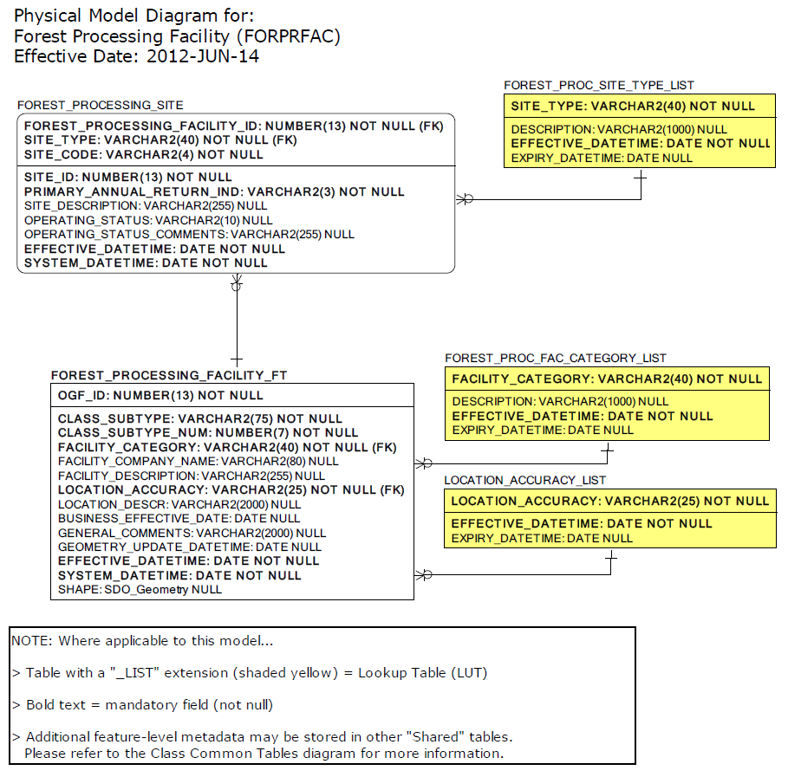
Data Class Change History

Data Class Name: Forest Processing Facility
Data Class Short Name: FORPRFAC
Date  YYYY-MM-DD | Details of Change
2014-12-09 | Outdated information in this model required a business area review. The model was simplified for ease of updates, with associations to GAAR migrated fields and shared tables dropped. This data class is now considered “Open Data”.
2012-06-12 | Data class converted to new GAAR structure.
2008-01-15 | GUT Expired: Forest Processing Facility  Geographic Unit Type expired as it has now been replaced by the 2 new GUTS.
2008-01-15 | New child Table added: FOREST_PROCESSING_SITE  Attached to Forest Processing Facility feature class table. Each Forest Processing Facility will have one or more Forest Processing Sites at that location.
2008-01-15 | Columns added:  FOREST_PROCESSING_SITE.SITE_TYPE  Identifies specific processing site type(s) found at a facility. Each facility will have one ormore processing sites, each dedicated to producing a specific product. E.g.: Pulp, Paper, Sawmill (GT 200 m3)  FOREST_PROCESSING_FACILITY.FACILITY_DESCRIPTION  Provides a general description about the facility  FOREST_PROCESSING_FACILITY.FACILITY_COMPANY_NAME  Identifies the registered company operating the facility.  FOREST_PROCESSING_FACILITY.FACILITY_CATEGORY  Identifies general category for facility e.g. Sawmill, Pulp /Paper / Paperboard.  See FOREST_PROCESSING_SITE.SITE_TYPE
2008-01-15 | Field dropped: FOREST_PROCESSING_FACILITY.FARWIS_IDENT  Dropped attribute due to remodeling this data class.  See FOREST_PROCESSING_SITE.SITE_CODE
2008-01-15 | New Columns added to new table:  FOREST_PROCESSING_SITE.OPERATING_STATUS_COMMENTS  Additional comments about the current operational status of the processing site e.g.: Sawmill destroyed by fire in 2005.  FOREST_PROCESSING_SITE.OPERATING_STATUS  Current known operating status of the processing site e.g. Active, Inactive, Unknown.  FOREST_PROCESSING_SITE.SITE_DESCRIPTION  Additional short description about the processing site.  FOREST_PROCESSING_SITE.PRIMARY_ANNUAL_RETURN_IND  Yes/No indicator whether the annual report submitted to the MNR for the entire facility’s operations is filed under one of the primary processing site (Site Code) found at the facility.  FOREST_PROCESSING_SITE.SITE_ID  New attribute: Unique business identifier used by FARWIS and eFAR.  FOREST_PROCESSING_SITE.SITE_CODE  Identifies MNR assigned unique code for each forest processing site in Ontario e.g. 1102 (DomtarInc. paper mill, Dryden)
2008-01-15 | GUTS added to revised model:  • Forest Processing Facility - Unlicensed  • Forest Processing Facility - Licensed
2007 | New Column: FOREST_PROCESSING_FACILITY.FACILITY_COMPANY_NAME  Identifies the registered company operating the facility.
2007 | New Column: FOREST_PROCESSING_SITE.SITE_CODE: Identifies MNR-assigned unique code for each forest processing site in Ontario e.g. 1102 (Domtar Inc. paper mill, Dryden)
2007 | New Column added: FOREST_PROCESSING_SITE.PRIMARY_ANNUAL_RETURN_IND  Yes/No indicator whether the annual report submitted to the MNR for the entire facility's operations is filed under one of the primary processing site (Site Code) found at the facility.
2007 | New Column: FOREST_PROCESSING_SITE.SITE_DESCRIPTION (additional short description about the processing site).
2007 | Retire GUT: Forest Processing Facility  Geographic Unit Type expired as it has now been replaced by Forest Processing Facility - Licensed, and Forest Processing Facility - Unlicensed.
2007 | New GUT for revised model: Forest Processing Facility - Unlicensed
2007 | New Column: FOREST_PROCESSING_SITE.OPERATING_STATUS_COMMENTS:  Additional comments about the current operational status of the processing site e.g.: 'Sawmill destroyed by fire in 2005.'
2007 | New child table: Attached to FOREST_PROCESSING_SITE feature class table. Each Forest Processing Facility will have one or more Forest Processing Sites at that location.
2007 | New Column: FOREST_PROCESSING_SITE.SITE_ID as a unique business identifier used by FARWIS and eFAR.
2007 | New Column added: FOREST_PROCESSING_FACILITY.FACILITY_CATEGORY  Identifies general category for facility e.g. Sawmill, Pulp /Paper / Paperboard. Also refer to FOREST_PROCESSING_SITE.SITE_TYPE
2007 | New Column: FOREST_PROCESSING_SITE.OPERATING_STATUS  Current known operating status of the processing site e.g. Active, Inactive, Unknown
2007 | New Column: FOREST_PROCESSING_SITE.SITE_TYPE  Identifies specific processing site type(s) found at a facility. Each facility will have one or more processing sites, each dedicated to producing a specific product. E.g.: Pulp, Paper, Sawmill (GT 200 m3)
2007 | New GUT added: Forest Processing Facility - Licensed
2007 | New Column: FOREST_PROCESSING_FACILITY.FACILITY_DESCRIPTION  Provides a general description about the facility
2007 | Dropped Column: FOREST_PROCESSING_FACILITY.FARWIS_IDENT  due to remodelling this data class. See FOREST_PROCESSING_SITE.SITE_CODE
2002 | NEW Data Class
Data Description
Please refer to the metadata record for the data description.

